1.Goods consigned from (Exporter's business  name, address, country)不能超过四行 |  |  |  | 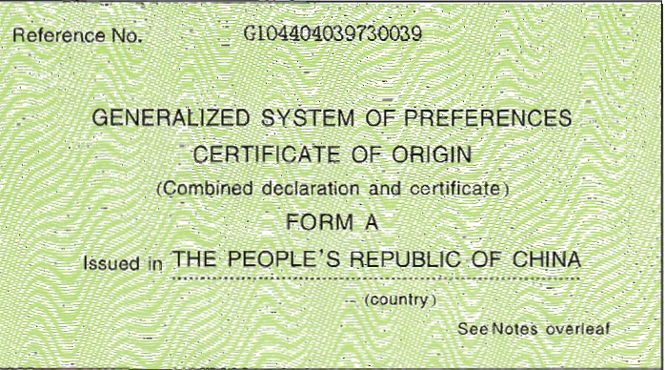  FORM A
2.Goods consigned to(Consignee' name, address, country)

3.Means of transport and route (as far as known)  ON/AFTER JULY. 17, 2010  FROM SHUNDE, CHINA  TO ALGIERS, ALGERIA BY SEA. |  |  |  | 4.For Official use
5.Item  number  1 | 6.Marks and numbers of packages  N/A | 7.Number and kind of packages; description goods  TWO HUNDRED AND TWENTY NINE (229) CTNS OF  COFFEE MAKER |  |  | 8.origin criterion  (see Notes overleaf)  “P” | 9.Gross weight or other quantity  5293.PCS | 10.Number and date of invoices  CI299-10003 JULY.17,2010
11.Certification  It is hereby certified, on the basis of control carried out, that the declaration by the exporter is correct.  ………………………………………………………  Place and date, signature and stamp of certifying authority |  |  | 12.Declaration by the exporter  The undersigned hereby declares that the above details and statements are correct; that all the goods were produced in  CHINA  ……………………………………………………………  （country）  and that they comply with the origin requirements specified for those goods in the Generalized System of Preferences for goods exported to  ALGERIA  …………………………………………………………….  (importing country)  ……………………………………………………………..  Place and date, signature of authorized signatory

